

COVID-19

Responsible Visitor Code

**Visitors must:**

* Book visits in advance for a specific day, time, and length of visit
* Check in with the Registered Manager at the Care Home on the day prior to their visit, to ensure the situation in the Home has not changed
* Be free of any COVID-19 symptoms on the day of their visit
* Not be unwell on the day of their visit
* Hand sanitisation
* Provide the necessary information required by the Care Home at the visits (e.g. honest response to screening requirements about COVID-19 risk factors to support track and trace guidance
* Comply with the infection prevention and control measures, including a temperature test, mandatory hand hygiene the use of PPE as required and social distancing requirements, remaining in the designated visiting area
* supervision of all visits to ensure social distancing and infection control measures are always adhered to.
* Ensure that any gifts brought to give to the individual they are visiting can be sanitized, in line with relevant infection prevention and controls (IPC) guidance.

Should a visitor not follow the Responsible Visitor Code, Omega Elifar Ltd reserves the right to refuse that individual’s access to visiting.

**Please note that should circumstances change or there is a resurgence of COVID-19, Omega Elifar Ltd will revise the Visitor guidelines in accordance with the advice from**

**Public Health England and the NHS.**

**Safety measures implemented for visitors across all our care homes**

**HEALTH QUESTIONNAIRE 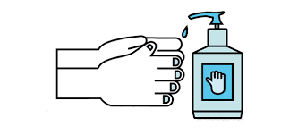HAND SANITISATION 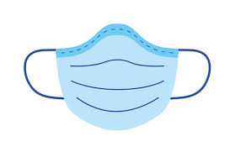MANDATORY PPE**

**UPON ENTRY**

**SOCIAL DISTANCING  RESTRICTED ACCESS** **ENSURE GIFTS ARE SANITSED**

**AVOID PUBLIC**  **ENSURE YOU ARE 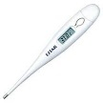 TEMPERATURE**

**TRANSPORT WHERE FEELING WELL SCREENING POSSIBLE**